NAME: J SATYA SRIKAR
ROLL NO:A24126552259
BRANCH AND SECTION:CSM-B
COURSE NAME: FULL STACK WEB DEVELOPMENT
COURSE CODE:23CM4121

Experiment:02
Date:
Title: Design Webpage using HTML5 & CSS3

Objective:
To create a static hotel booking webpage using HTML and CSS, displaying room details, images, prices, navigation links, and booking buttons

System Requirements:
- Hardware: Processor (e.g., Core i5), RAM (e.g., 8GB), Storage.
- Software: Operating System (e.g., Windows 11 / Linux), Code Editor (e.g., VS Code), Browser (e.g., Chrome), Runtime/Database (e.g., Node.js, MongoDB). [1, 2]

Source Code:

<!DOCTYPE html>
<html lang="en">

<head>
<meta charset="UTF-8">
<meta name="viewport" content="width=device-width, initial-scale=1.0">
<title>Static webpage</title>
</head>
<style>
.navlist{
display: flex;
gap: 25px;
list-style-type: none;
justify-content: flex-end;

}
a{
text-decoration: none;
}
.room-container{
display: flex;
gap: 20px;
justify-content: center;
flex-wrap: wrap; /*Pushes the containers into next line on small screens*/
padding: 50px;
}
.room-box{
border: 2px solid #ddd;
border-radius: 10px;
padding: 15px;
width: 500px;
text-align: center;
box-shadow: 2px 2px 10px rgba(0,0,0,0.1);
}
.room-box img{
width: 100%;
}
.room-box button{
color: blue;
border: 2px solid #ddd;
border-radius: 15px;
width: 20%;
height: 5%;
font-family: 'Lucida Sans', 'Lucida Sans Regular', 'Lucida Grande', 'Lucida Sans Unicode', Geneva, Verdana, sans-serif;
}

</style>
<body>
<header>
<center>
<h1>THE STATIC WEBPAGE</h1>
</center>
<nav>
<h3>THE KING BOOKINGS</h3>
<ul class="navlist">
<a href=""><li>HOME</li></a>
<a href=""><li>HOTELS</li></a>
<a href=""><li>BOOKINGS</li></a>
<a href=""><li>ABOUT US</li></a>
</ul>
</nav>
</header>
<h2 style="text-align: center;">THE ROOMS WE HAVE</h2><br>
<!-- The Flexbox grid for your rooms -->
<div class="room-container">

<div class="room-box">
<!-- Replace the src link with your actual image path -->
<img src="D:\CSM259(3-1)FS\CSM259(3-1)FS\Record\Experiment2-Week2\media\media\img1.jpg" alt="Room 1 Image">
<h3>Room 1</h3>
<p>Big bed, AC, and premium vibes. ₹2000/night.</p>
<button>BOOK NOW</button>
</div>

<div class="room-box">
<img src="D:\CSM259(3-1)FS\CSM259(3-1)FS\Record\Experiment2-Week2\media\media\img2.jpg" alt="Room 2 Image">
<h3>Room 2</h3>
<p>Ocean view with a crazy balcony. ₹3500/night.</p>
<button>BOOK NOW</button>
</div>

<div class="room-box">
<img src="D:\CSM259(3-1)FS\CSM259(3-1)FS\Record\Experiment2-Week2\media\media\img3.jpg" alt="Room 3 Image">
<h3>Room 3</h3>
<p>Standard room. Doesn't break the bank. ₹1200/night.</p>
<button>BOOK NOW</button>
</div>

<div class="room-box">
<img src="D:\CSM259(3-1)FS\CSM259(3-1)FS\Record\Experiment2-Week2\media\media\img4.jpg" alt="Room 4 Image">
<h3>Room 4</h3>
<p>VIP Suite. Strictly for the bosses. ₹5000/night.</p>
<button>BOOK NOW</button>
</div>

</div>
</body>

</html>
STEPS TO EXECUTE:
- Open vs code
- Click on run in menu
- Click on Debug to Run
- Select browser and click run

OUTPUT: 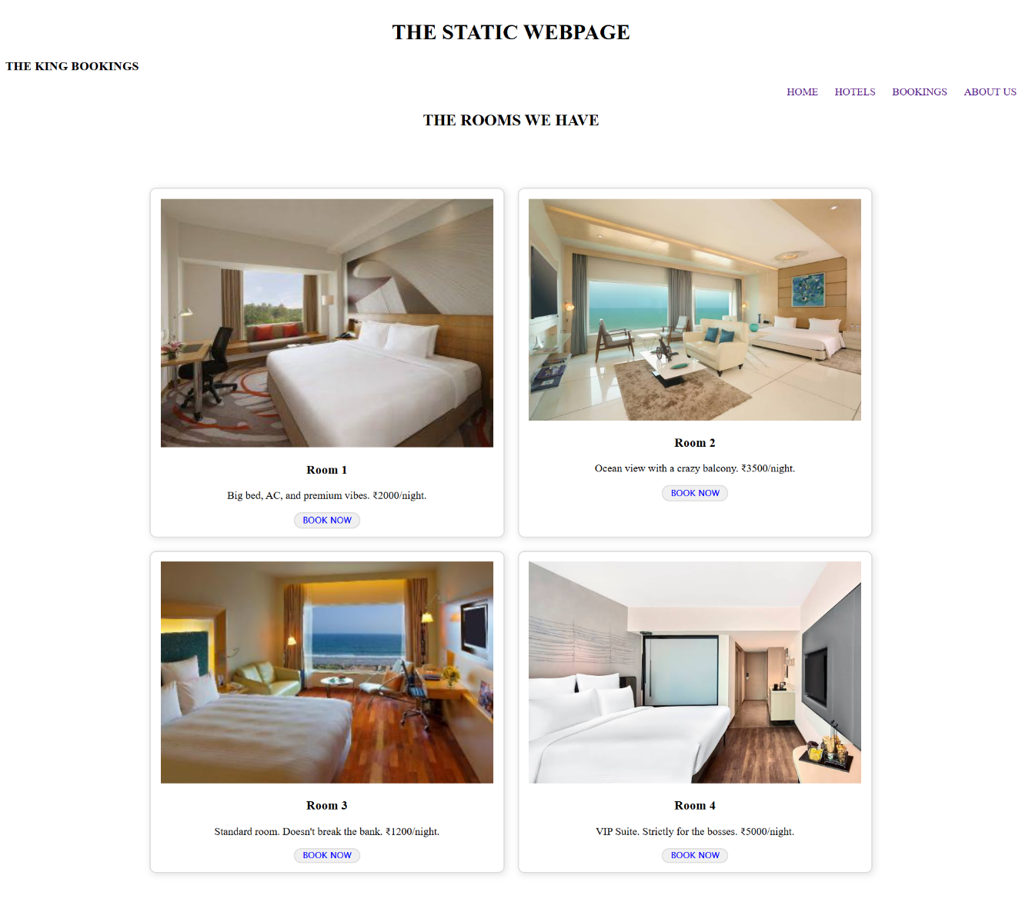
RESULT: Successfully executed a static webpage with CSS

